# UAT Test – Bug 1 Report – assignment 4

## by Abhimanyu Bhat - 11732514

### Bug 1 – Incorrect calculation of fines: -

|  |  |  |  |  |  |  |
| --- | --- | --- | --- | --- | --- | --- |
| **Test #** | **Description of tasks** | **Steps to execute** | **Expected results** | **Pass** | **Fail** | **Comments** |
| 1 | Checking whether the fines imposed after a due date is accurate | 1. Add patrons to the database | Patron is created | Yes |  |  |
|  |  | 2. Add books to the database (name, title, etc.) | Book entry is created | Yes |  |  |
|  |  | 3. Take out a loan for a book | Book loan is taken out | Yes |  |  |
|  |  | 4. Increment date to a date one day past due date using T | Date is incremented past due date | Yes |  |  |
|  |  | 5. Return the book one day after due date | Book is shown to be overdue |  | Yes | No fine imposed despite being Overdue |

#### Screenshot of borrowing and returning books one day after the due date:

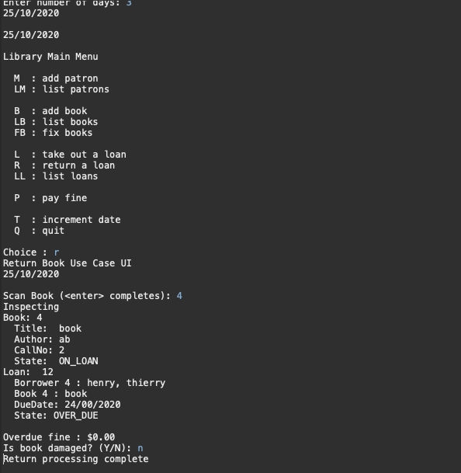

#### Screenshot of borrowing and returning books on the same day:

